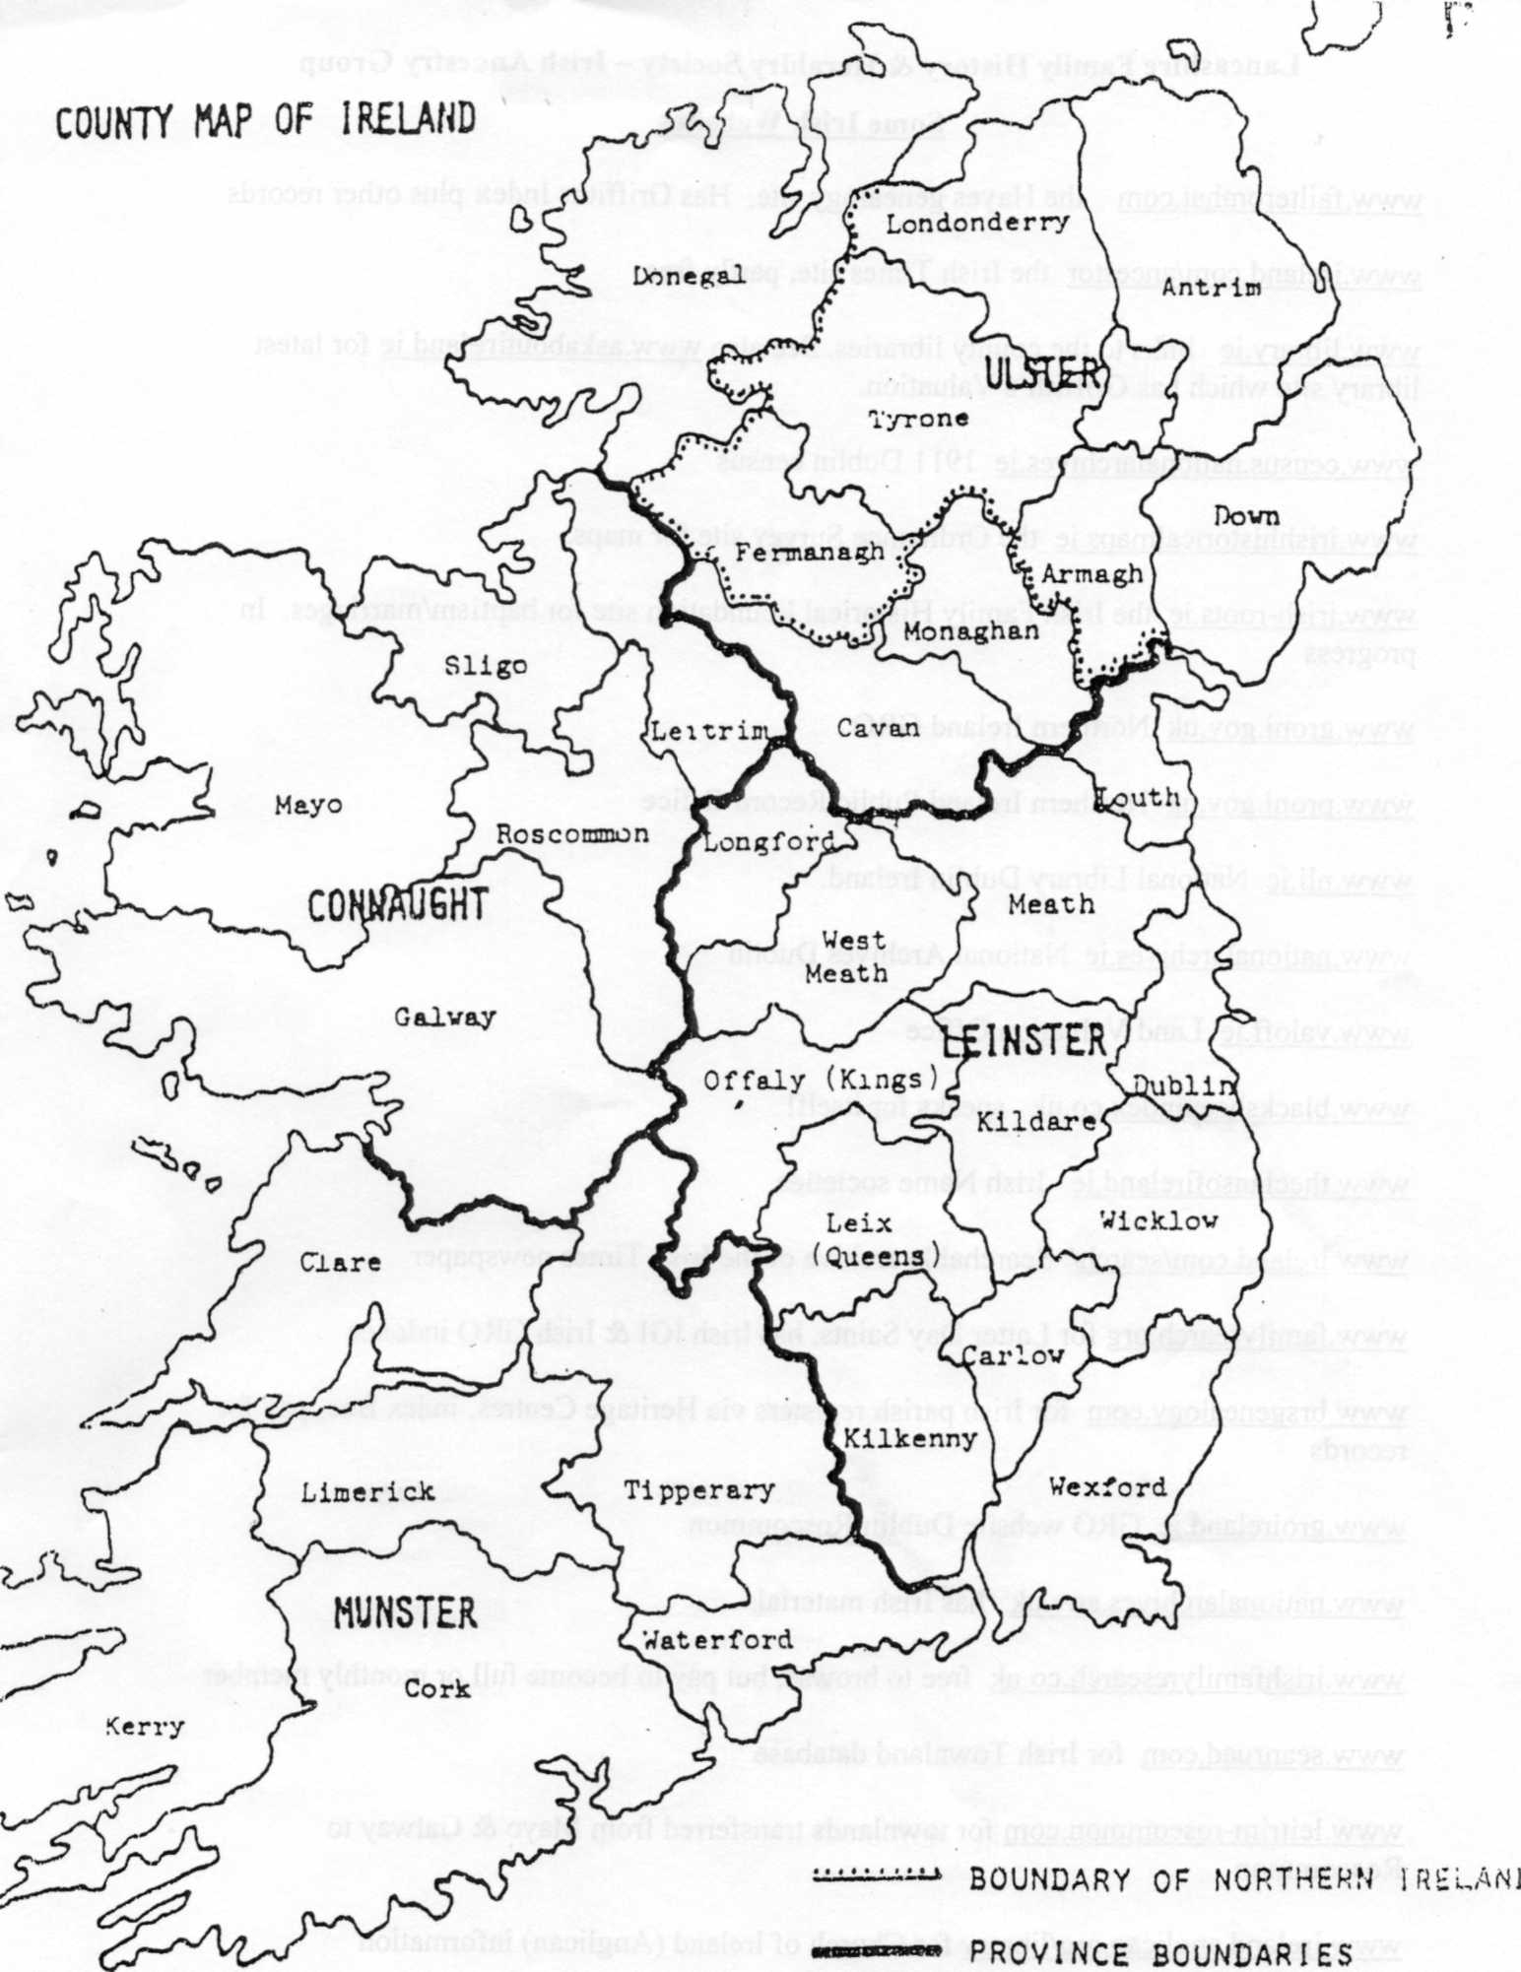
Permission is granted for nonprofit organizations such as historical and genealogical societies to reproduce this outline in full or 1n part. Please give proper credit.
Copyright © 1981 by Corporation of the President of The Church of Jesus Christ of Utter-day Saints.

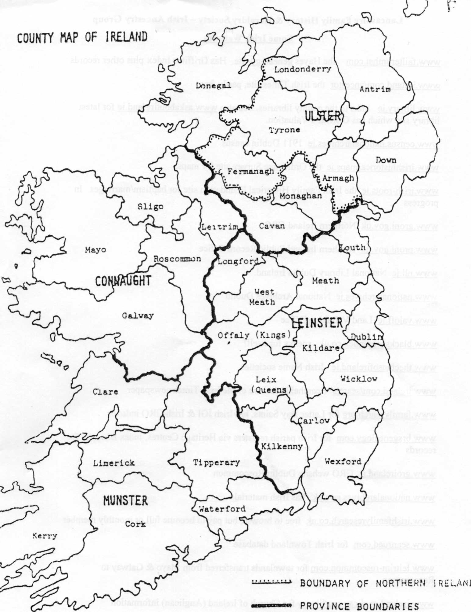
Permission is granted for nonprofit organizations such as historical and genealogical societies to reproduce this outline in full or 1n part. Please give proper credit.
Copyright © 1981 by Corporation of the President of The Church of Jesus Christ of Utter-day Saints.

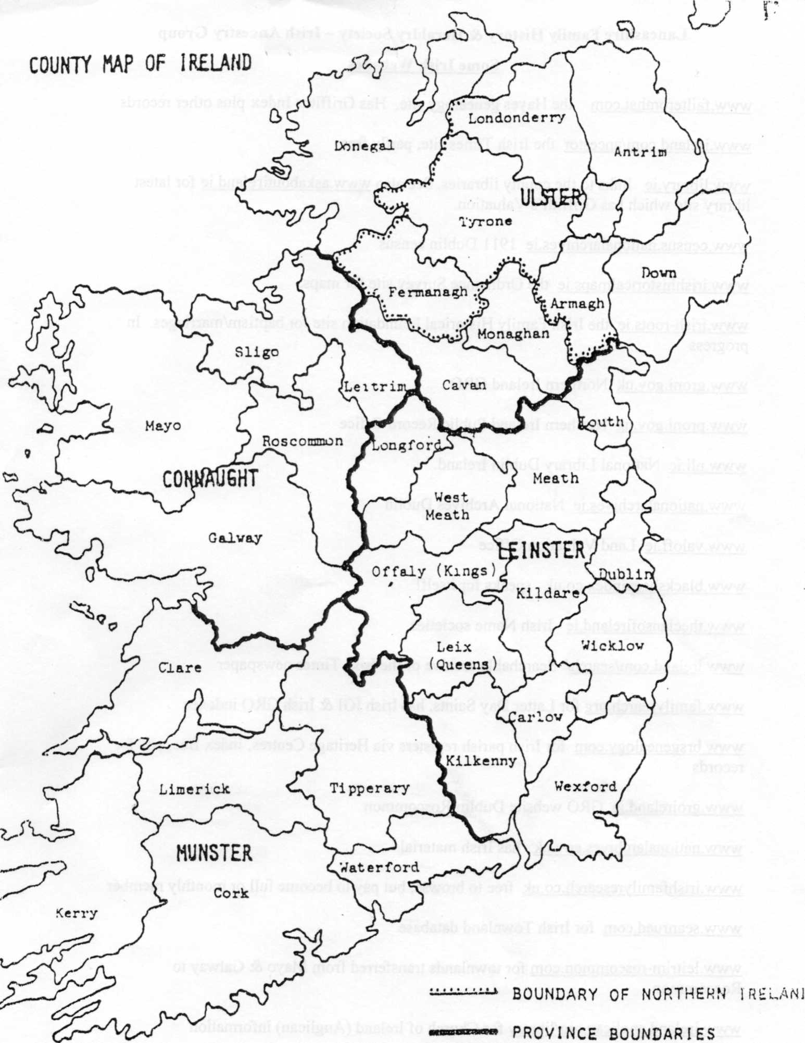
Pefmissicn is granted for nonprofit organizations such as historical and genealogical societies to reproduce this outline in full or 1n part. Please give proper credit.
Copyright © 1981 by Corporation of the President of The Church of Jesus Christ of Utter-day Saints.

Lancashire Family History & Heraldry Society - Irish Ancestry Group
Some Irish Websites
www.failteromhat.com the Hayes genealogy site. Has Griffiths Index plus other records www.ireland.com/ancestor the Irish Times site, partly free
www.library.ie links to the county libraries. See also www.askaboutireland.ie for latest library site which has Griffith's Valuation.

www.census.nationalarchives.ie 1911 Dublin census

www.irishhistoricalmaps.ie the Ordinance Survey site for maps.

www.irish-roots.ie the Irish Family Historical Foundation site for baptism/marriages. In progress
www.groni.gov.uk Northern Ireland GRO www.proni.gov.uk Northern Ireland Public Record Office www.nli.ie National Library Dublin Ireland. www.nationalarchives.ie National Archives Dublin www.valoff.ie Land Valuation Office www.blacksheepindex.co.uk speaks for itself! www.theclansofireland.ie Irish Name societies,
www.ireland.com/search/ Searchable archive of the Irish Times newspaper
www.familysearch.org for Latter Day Saints, has Irish IGI & Irish GRO indexes
www.brsgenealogy.com for Irish parish registers via Heritage Centres, index free, pay for records
www.groireland.ie GRO website Dublin/Roscommon www.nationalarchives.gov.uk has Irish material
www.irishfamilyresearch.co.uk free to browse, but pay to become full or monthly member www.seanruad.com for Irish Townland database

www.leitrim-roscommon.com for townlands transferred from Mayo & Galway to Roscommon
www.ireland.anglican.org/librarv for Church of Ireland (Anglican) information www.ancestryireland.com Ulster Historical Foundation
www.irishgenealogy.ie free search facility pre 1900 church BMD (Irish Government site)

© LFHHS 2012

IRISH ANCESTRY

General Register Office, Government Offices, Convent Road, Roscommon - post General Register Office, 3rd Floor, Block 7, Irish Life Centre, Lower Abbey Street, Dublin 1 - in person. BMD's www.groireland.ie .

General Register Office. Oxford House, 49/55 Chichester Street, Belfast BT1 4HL www.groni.gov.uk BMD's

Church Body Library, Braemor Park, Churchtown, Dublin 14 Parish Registers. www.ireland.anglican.org

National Archives, Dublin, Bishop Street, Dublin 8. Wills, Tithe Applotment Books www.nationalarchives.ie/genealogy

Public Record Office of Northern Ireland, 66 Balmoral Ave, Belfast BT9 6NY Ulster Covenant, Freeholders Records, Will Calenders, www.proni.gov.uk

National Library. 23 Kildare Street, Dublin 2. www.nli.ie Church of Ireland and Catholic Registers

Church of Latter-Day Saints Family History Centre
Temple Way, Hartwood Green, Chorley 0125 722 6145

www.irishtimes.com /ancestor/surnames Irish Surname Distribution. BMD's (pay to view)

www.familysearch.org BMD's 1845 - 1959 index of civil registration

www.census.nationalarchives.ie 1901 & 1911 census of Ireland

www.irishorigins.com Griffiths Valuation, 1851 Dublin City Census, Wills Pay to view

http://griffiths.askaboutireland.ie/gv4/gv family search form.php free access to Griffiths Valuation

www.ancestryireland.com Ulster Historical Foundation, pay to view, will undertake research
www.ancestry.co.uk/ireland Irish databases, BMD's www.irishgenealogy.ie BMD's for Carlow, Cork, Dublin, Kerry www.belfastciry.gov.uk/burial records/search.asap
26.3.2012 - Produced by Ormskirk & District Family History Soc. (odfhs.org.uk) P.O. Box 213, Aughton, Ormskirk, L39 5WT

